Jordan Dube

Q1) In the terminal type top, what do you see, describe shortly? (use man pages to understand)

In the terminal type ps, what do you see, describe shortly? (use man pages to understand,)

Now compare and contrast top and ps. What is the difference between top and ps? (Hint: Which one is dynamic, which one is static?)

* The top command displays the users on the server and the tasks that are running, as well as how much memory and CPU processing power is being used. This list updates frequently.
* Ps gives a smaller interface that contains limited information about the currently running processes. It does not repeatedly update.

Q2) In the terminal type ps -axu, what do you see, describe? (use man pages to understand, do not copy and paste just explain in a few words)

* A list of all the processes with the user information within the system.

Q3) Modify this program and print the parent process id in addition to the current process id (Look at the lecture slides). Which function returns parent process id?

* the getppid() function returns the parent PPID of the current process.

Q4) Draw process graph.

_____*printf___*exit

|

* *Main_____*printf____*fork_____*printf___*exit

Q5) Look at the program below. It has several fork() and printf() calls. How many A, B and C will be printed? (Use process graph, then run the program)

* 1 A, 2 Bs, and 4 Cs will be printed.

Q6) 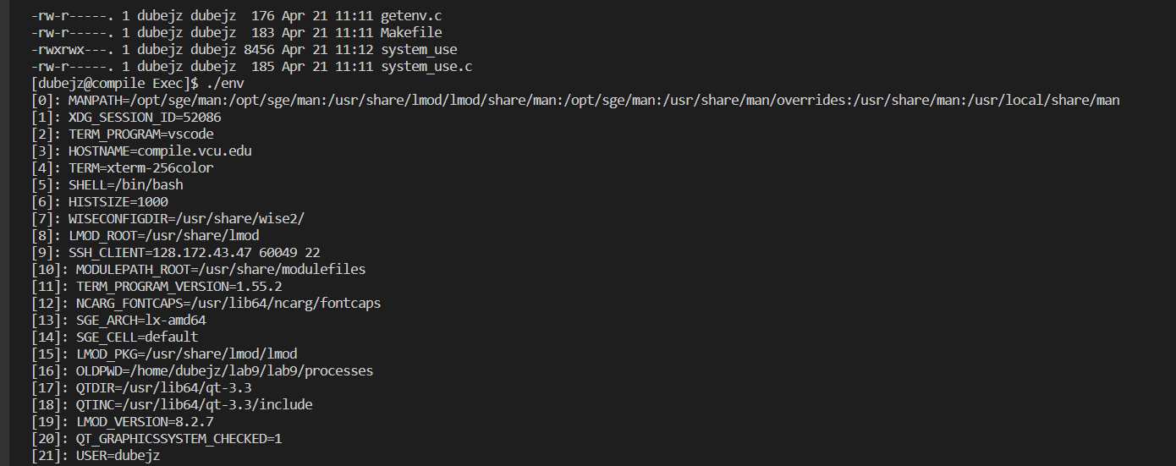

Q7)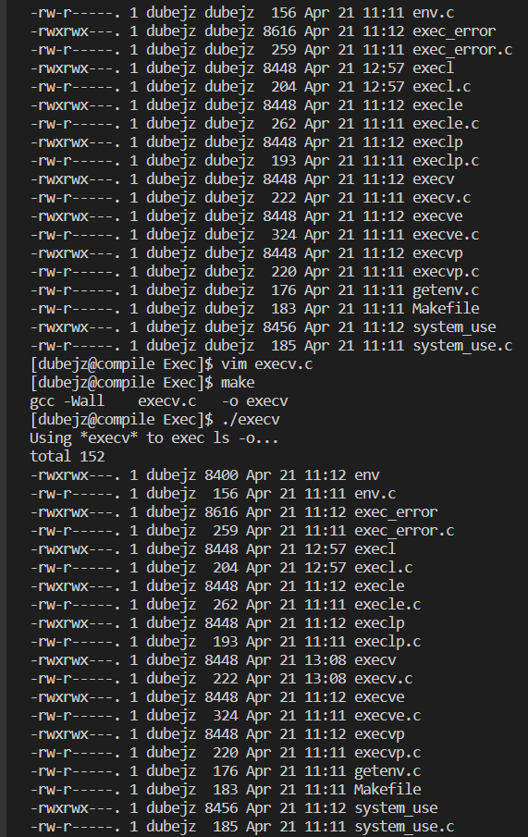

Q8)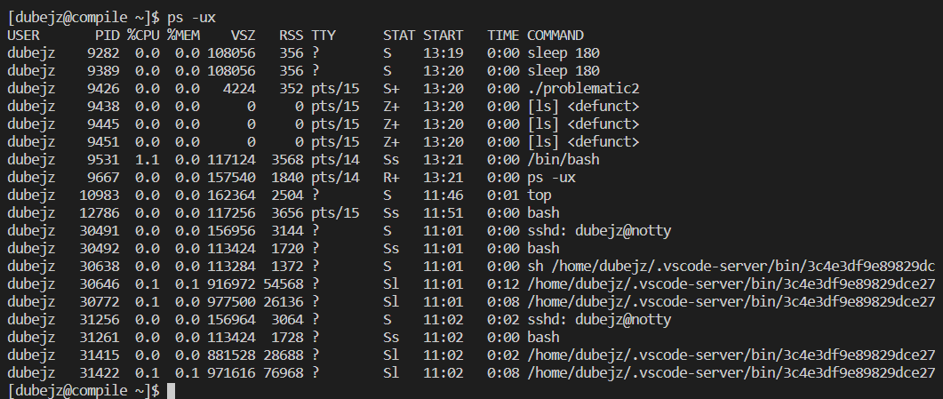

Q9) Do you see any zombies now?

* No Zombies present.

Q10) What is the difference between wait and waitpid in your own words?

* Wait only returns the status of the child, while the waitpid can use more status options and you can specify a single process to wait for.